DESD Program Committee Meeting Agenda

Monday, 3:00 PM – 4:00 PM Eastern

November 8, 2020

Attendees were

Jim Byrne | Lynne Goodman
Mark Campagna | Leah Parks
Steve Dahms | Bill Roy
Doug Davis | Jorge Spiltinak
David Donelly | Bill Szymczak
Nadia Glucksberg | Gerry VanNoordennen

Recap/Lessons Learned from ANS 2020 Annual Conference DESD Sessions – June 8-11 and ANS 2020 Utility Working Conference DESD Sessions – August 9-12, 2020

For the virtual meetings it was believed that it was easier for the presenter to control their own slides all other things being equal. However, there will be times when the Session Chair will need to do this if the presenter is unfamiliar with Zoom or there are issues with their connection to the meeting.
Communicate in advance to your presenters and make sure their most recent presentation is loaded on the system
The sessions are shorter than we are use to and the Session Times are fixed so time discipline is important

ANS 2020 Winter Conference – November 15-19, 2020 Chicago, Illinois

The following are the DESD Session Topics presented at the Winter Meeting. As of the time of my writing of these minutes we have had 130 participants in the Economics of Low-Carbon Energy and Role of Nuclear Power Session and over 40 participants in the Grid Modelling Considerations for Nuclear Energy. Both sessions were very informative and the organizers and session chairs did a wonderful job. For the General Topics session we have gone from 5 papers to 3 and one of the author of one of the remaining papers has not yet registered for the meeting.

Economics of Low-Carbon Energy and Role of Nuclear Power
Panel|Session Chair: Yoon I. Chang Session Organizer – Jan Van Erp

Grid Modelling Considerations for Nuclear Energy
Panel|Cosponsored by OPD|Session Chair: Leah Spradley Parks

Building Up Decommissioning Staff Credentials for Future Decommissioning Projects
Panel|Cosponsored by ETWDD|Session Chair: Lawrence E. Boing

Innovative Characterization Techniques in Support of Decommissioning
Panel|Session Chair: Jay Peters

General Topics in Decommissioning
Session Chair: James J. Byrne

Community Advisory Panels
Panel|Session Chair: Gerard P. van Noordennen

2021 Annual Meeting – June 17 – 21, 2021 - Providence RI
Two sessions were proposed for this meeting along with the standard General Topics session

Decommissioning in the Northeast – Needed an organizer and Gerry, Nadia, Leah and Mark agreed to help with this session. I need a volunteer to be the leader or a commitment that each of you will get one presenter.

Environmental Issues in the Northeast – Nadia Glucksberg – Focus on Radiological Fracking Waste – Nadia has not begun to organize this session

2021 Utility Working Conference – August 8-11, 2021 Marco Island, Florida (organization not started)

Volunteers to help organize this meeting are – Jim Byrne, Mark Campagna, Lynne Goodman, Rich St. Onge and Gerry Van Noordennen,

Will start planning following the Winter Meeting – looking for additional volunteers. We will probably need to organize seven sessions

2020 Proposed Topics were as follows need to think of new topics especially with new wave of plant shutdowns

- Session 1 – Introduction to Commercial Nuclear Plant Decommissioning.
- Session 2 - Spent Fuel Management options during the phases of site decommissioning.
- Session 3 - Status of Decommissioning Projects in progress and completed to date.
- Session 4 - Decommissioning Planning, Estimating and Assumptions: Examining past planning efforts against actual execution performance.
- Session 5 - Decommissioning Nuclear Safety, Security, and Safety Culture.
- Session 6 - Regulatory perspectives and updates on Commercial Decommissioning processes
- Session 7 - Innovation and Optimization in Decommissioning: Lessons Learned on Technology and Approaches to Shorten Project Durations.

2021 Decommissioning Embedded Topical Meeting – October 31 – November 4, 2021 – Washington, DC

General Chair – Jim Byrne
Technical Program Chairs – Sue Aggarwal (Decommissioning), Nadia Glucksberg (Environmental Science), Leo Lagos (Robotics and Remote Systems)
Publication Chairs – Jay Parks (DESD), Young Soo Park (RRSD)
Technical Program Committee –

Larry Boing
Frazier Bronson
Mark Campagna
Joe Carignan
Gene Carpenter
Michael Dalmaso
Noah Fetherston
Genia McKinley
Jean Pabon
Leah Parks
Jean Plummer
Marty Plys
Mike Serrato
Rich St. Onge
Young Soo Park
Gerry Van Noordennen

- Technical Program Chairs will each be responsible for 4 sessions, develop topics for each session and recruit session organizers for each session.
- Thoughts for a base schedule:
  - Opening Plenary – Monday PM (Big Wigs from DOE, Foreign Countries, International Institutions)
  - Paper Presentation Sessions – Tuesday and Wednesday AM, PM
  - Poster Session (if necessary) – Tuesday Evening
  - Closing Plenary – Wednesday Evening – Track Chairs to give a report out of their track (Another alternative is to have session chairs give a short report, use Power Points Slides so we can send them to attendees after the meeting)

We need at least 72 papers to fill out program without a Poster Session
- “Save the Date” Flyer Finalized and distributed.
- Draft Call for Papers Attached
- Finances
  - This will be a paper conference so we will need paper reviewers for each track. One of the issues with a paper conference at a National Meeting is that there is a page charge of $25/page. (Possibly we can offset this cost)
  - If we want to have a reception with the Tuesday Poster session we will have to raise some money. I asked ANS what the Universities paid for their mixers at the last ANS Meeting in DC and the average was about $25,000.
  - Also, in order to offset Page Charges we would need to raise $10,000 (4 pages * $25/page* 100 papers)
  - Therefore, we would need to raise $35,000 to pay for the reception and the page charges any thoughts on how to raise this money would be appreciated. (Note we could not ask the same people ANS asks). Jim will talk to ANS if there is any logistical way we could do this at a National Meeting.
- Subsequent to the meeting I was contacted by John Kelly, he and Gail Marcus want to talk about featuring the NS Savannah at an ANS Meeting. More details on this later.

Attachment
DESD/RRSD 2021 Embedded Topical

TITLE BLOCK (use example from ATH 2018 – see example below)

Title:
DESD/RRSD 2021 “Tech + Green = Clean”
20201 Winter Meeting Embedded Topical
October 31 – November 4, 2021 Washington, DC Marriot Wardman Park Hotel

CALL FOR PAPERS

EMBEDDED TOPICAL MEETING CHAIRS

General Chair
James Byrne, Byrne & Assoc., LLC

Technical Program Chairs
Sue Aggarwal, NMNT International
Nadia Glucksberg, Haley & Aldrich, Inc.
Leo Lagos, Florida International University

IMPORTANT DUE DATES (No Abstract Submission is Needed)
Draft Summary Paper Submission: Monday, July 5, 2021
Review Notification: Monday, August 2, 2021
Final Papers: Monday, August 23, 2021
Winter Meeting: Sunday October 31, 2021

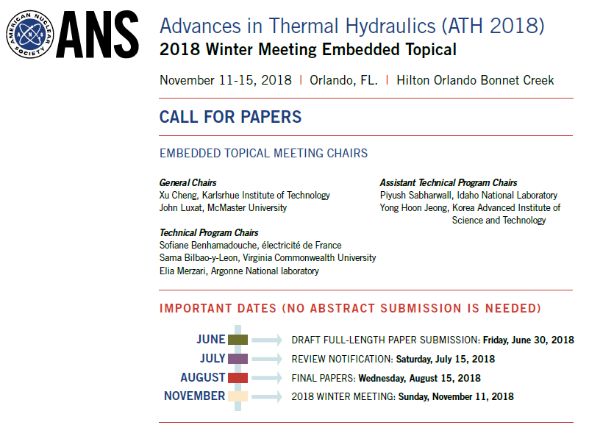

DESCRIPTION OF EMBEDDED TOPICAL
This embedded topical meeting is a joint venture between the Decommissioning and Environmental Services Division (DESD) and Robotics and Remote Systems Division (RRSD). Authors are invited to participate in this event to exchange ideas and knowledge, and to submit papers covering advances in DESD and RRSD topics listed in this announcement. Accepted papers not selected for an Oral Presentation will be included in a Poster Session.

GUIDELINES FOR SUBMISSIONS
Authors are required to follow the “Guidelines for Transactions Summary Preparation” provided
on the ANS website at https://ans.org/pubs/transactions/. Summaries must be submitted electronically in Adobe Acrobat (PDF) format via the ANS Electronic Paper Submission and Review System. Summaries not based on the ANS Template will be rejected.
Please submit summaries describing work that is NEW, SIGNIFICANT, and RELEVANT to
the nuclear industry to [NEED WEBSITE]. Papers should be one to four pages. ANS will publish all accepted summaries in the Transactions. Papers will incur a $25 per page publication fee. Papers are presented orally at the meeting, and presenters are expected to register for the meeting.

FOOTER FIRST PAGE – TO BE UPDATED
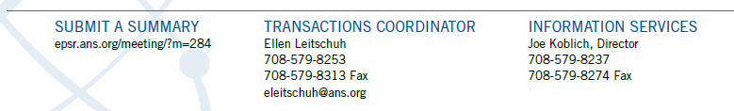
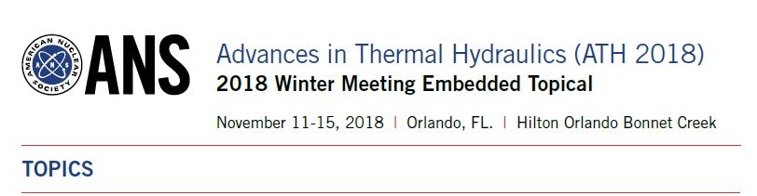
HIGH QUALITY PAPERS (4 PAGE MAXIMUM) ARE SOLICITED FOR THE FOLLOWING TOPICS
ROBOTICS AND REMOTE SYSTEM DIVISION

Robotics and Remote Systems
1a. Robotics & Remote Systems for Surveillance in Hazardous Environments – tanks, H-canyon, contamination monitoring etc.
1.b Nuclear materials handling – radiography, conveyance, glovebox robotics
1.c Nuclear Plant Maintenance and Operations
1.d Robotics & Remote Systems for Nuclear Waste and Spent Fuel Handling
1.e Robotics & Remote Systems in Commercial Power – SMR refueling, spent fuel management, 1.f Dry cask storage monitoring (some overlap with surveillance)
1.g Radiation Damage and Hardening

Special Topics:
2a. Artificial Intelligence in Robotics & Remote Systems
2.b Telerobotics
2.c Robotics Operating System (ROS)
2.d Nuclear Emergency Response

RRSD/DESD COMBINED SESSIONS
Combined Topics:
3a. Robotics & Remote Systems for Decommissioning and Waste Disposal
3.b Robotics & Remote Systems for Environmental Remediation and Monitoring

DECOMMISSIONING AND ENVIRONMENTAL SERVICES DIVISION

Environmental
4a. Emerging (Non-Radiological) Compounds
4b. Sampling Methods/Techniques
4c. Groundwater Modeling and Investigations
4d. Integrating Site Closure (non-Rad) and License Termination (rad) during Decommissioning
4e. Nuclear Innovation: Clean Energy Future (NICE Future): Progress on Key Activities for
4.f Advancing Policy and Technology
4.g Energy-Water Nexus: Nuclear Technology’s Potential to Provide Clean Water with Clean Energy
4.h The Path Towards a Low-Carbon Sustainable Energy Supply System
4i. Meeting Targets for Reduction of CO2 Emission without Causing Economic Damage
4j. Regulatory Framework for The Resumption of Operation for Decommissioning Power Reactors

Decommissioning (Planning, Execution & Lessons Learned)
5a. International Decommissioning
5b. US Decommissioning (both DOE and Commercial) and
5c. Innovative Technologies
5d. Regulatory Framework for Decommissioning

Paper acceptance will be based upon originality of the work, strictly implemented methods or models, quality of results, impact of the scientific advances to the field of thermal hydraulics, conclusions supported by data, proper citing of references, use of correct grammar and spelling, and adherence to ANS formatting requirements.

